Date: MAY 24 2021 File: C:\Karapetyan\18445 Резка заготовок\03_program\10\18445_10mm001.NST

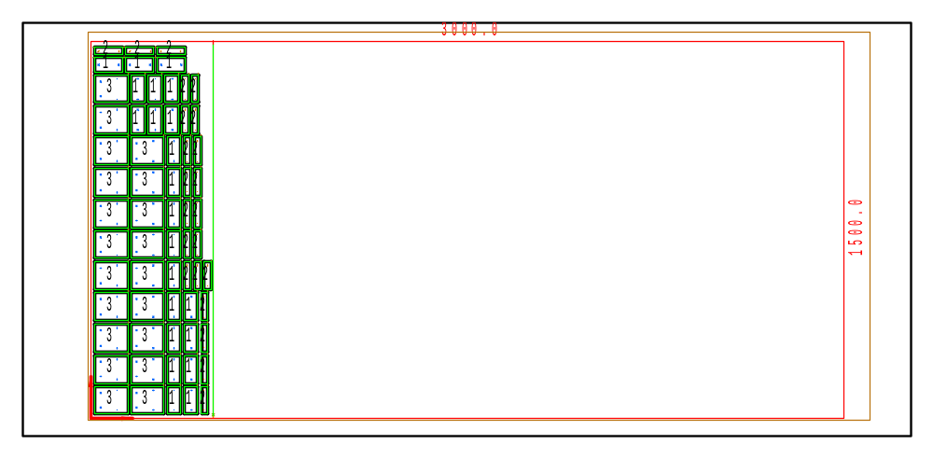

PART INFO
NC File Name: Ê!Å;Ä2LÅ5_10mm0011ËÍ
Draft no.: | Version:
Order no.: | Description:
SHEET Number of sheets: 1
Material: Steel | Sheet size: 3000 X 1500 | T= 10.0
No. of parts: 64 | Part size:
Part weight: | Sheet weight: 351.00 kg
MACHINE:
MODEL: ML3015EX |  | Con. name: SS400 |  | Table name: ML45CF_R_EX
Gas: O2 | Lens: 7.5 Inches |  | Nozzle diameter: 1.2
Speed: 1800 |  | Used laser power: 4500 |  | Beam diameter (kerf): 0.52
PROGRAM
Number: 4152 | File size: 8427 | Programmer:
Notes:
JOB TIME (min:sec)
Travel: 01:16 | Cut: 15:58 | Pierce: 10:30
Travel way: 29613.1 mm | Cutting way: 0 mm | Pierce Qty.: 108
Total time: 29:36

 | Part name | DX | DY | QTY
2 | Ê#Å;Ä>UIÅ.007.00.00.001_KËÍ | 26 | 110 | 22
3 | Ê#Å;.Ä>UIÅ.004.01.00.001_dËÍ | 130 | 110 | 20
1 | Ê#Å;Ä>UIÅ.004.02.04.002_<ËÍ | 54 | 110 | 22

